
THE INTERNATIONAL SCHOOL BANGALORE
GRADE 6 & 7 – NONVERBAL ENTRANCE EXAMINATION DETAILS

- SYLLABUS OUTLINE

In the Nonverbal Reasoning paper, students are expected to demonstrate pattern recognition, logical thinking, and visual problem-solving skills. The questions are designed to assess innate reasoning ability and do not require prior subject knowledge or curriculum-based learning.

Students will be presented with a variety of visual puzzles involving shapes, sequences, spatial patterns, and relationships between figures. These tasks test their ability to observe, compare, and deduce patterns based purely on visual input.

- QUESTION PAPER PATTERN
- Nature of Questions: Multiple Choice Questions (MCQs)
- Number of Questions: 20
- Duration: 30 minutes

- Sample Questions
- 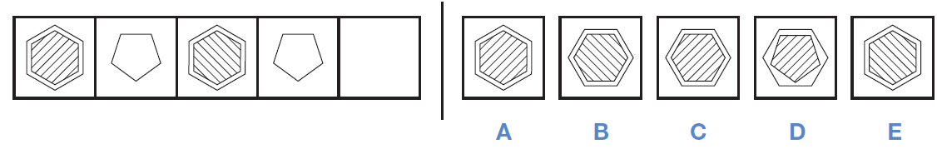

Answer : A
2. 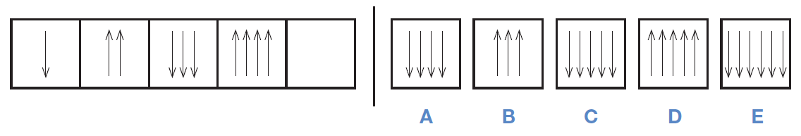
Answer : C

3. On the left of the example below are two shapes with an arrow between them. Decide how the second is related to the first. After these there is a third shape, then an arrow and then five more shapes. Decide which of the five shapes goes with the third one to make a pair like the two on the left.

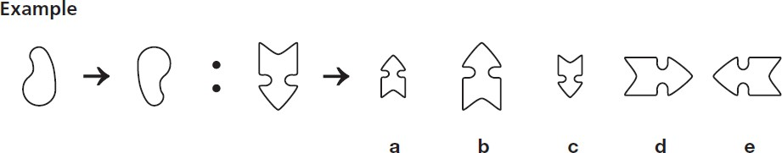
Answer : b

4. On the left of the example below there are two figures that are alike. On the right there are five more figures: one of these is most like the two figures on the left.

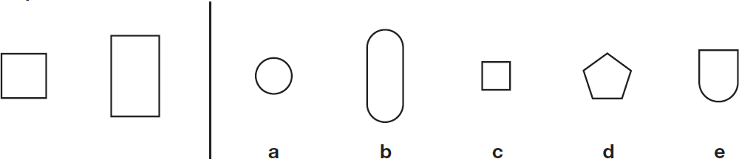
Answer : C

